Margaret Pilkington Memorial Fund - An Appeal Letter
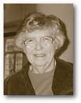 | The Class of ‘68 has initiated the setting up of a memorial fund to honour Ms Margaret Pilkington, former English teacher and Deputy Headmistress in the ‘60s and ‘70s, who has passed away last August.

What began as a small fund-raising idea among a few old classmates of setting up a Pilkington Scholarship, has now turned into a full-fledged fund-raising campaign, sanctioned by the school. By posting this notice in the YWGSAA web site, we hope to reach as many alumnae as possible to make this campaign a success.  Of the many ideas proposed, it has been decided that the donations will go to the setting up of a scholarship as well as the "Yat Pin Tin, Boon Mau Tien " (A Piece of Sky, Half an Acre of Field) slope-strengthening / mural project. | 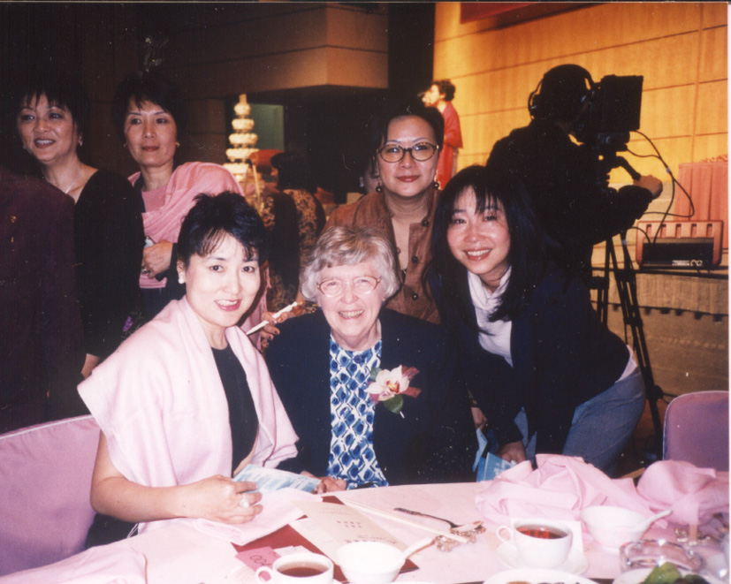  Ms Pilkington with Mak Wai-lim Rosanna (left), Cheung Yuen-ting Mabel (right), So Wai-ying Vivienne (at the back), class of 68, at the Centenary Dinner in 2000.

The simple criteria of selecting the recipient of the scholarship is set out below:

1 It has been decided a scholarship of HK$500 (plus a certificate of award) will be awarded to a Secondary Three student who has shown the greatest improvement in English during the academic year. It has been decided not to award the top English student in Secondary Three for the simple fact that she might win the Silcocks Scholarship anyway in Secondary Four. We hope the Pilkington Scholarship - Best Improvement In English Award could inspire a lot of other students to work harder in this crucial year if they think they too could stand a chance of winning the scholarship. The sum of HK$500 is set in line with other scholarships now in force such as the Silcocks Scholarship. The subject English is chosen for obvious reasons.

2. The student chosen must have good conduct. This condition is just added for good measure.

The slope-strengthening project to which our fund will also contribute, is a much needed undertaking, and requires a much larger sum of well over HK$100,000. Every dollar counts. So your generous donations will be greatly appreciated!

You can choose to donate HK$1,000, HK$500, HK$200 (or the equivalent of your local currency) or any amount you wish to donate by making your cheque or money order payable to Ying Wa Girls' School, and send it to Ying Wa Girls' School, 76 Robinson Road, Hong Kong. Please write "Margaret Pilkington Memorial Fund" at the back of your cheque or money order and indicate your year of graduation, if applicable. For your convenience, a reply slip is enclosed. Official receipts will be issued by the school. A set of souvenir bookmarks will also be issued as a token of thanks for your generosity. Donations of HK$100 and above will be tax-deductible in Hong Kong. For large overseas donations, the school could look for a tax agent if required.

Thanks to the highly efficient and hard working alumnae of ’65 and ’67 who have opened a bank account in Vancouver, donors in Canada can make deposits directly into any Scotiabank across Canada. This will save HK$50 transaction fee for each cheque the school receives. Please note that the bank account will be open only up the end of March 2004. For every donation made through this account, it is important that the donor will mail, fax or e-mail the reply slip back to the school so that we can issue the receipt and souvenir. The school’s address is:

Ying Wa Girls’ School, 76 Robinson Road, Hong Kong
Facsimile Number: (852) 2858 8669

E-mail Address: school@ywgs.edu.hk

Details of the bank account are as follows:

Bank: Scotiabank

Account name: Ying Wa Girls' School-Pilkington Memorial Fund

Account number: 80390 01692 26 (all 12 digits)

For those who wish to make donations by electronic remittance to the account, please include the institution number as follows:

Account number: 80390 01692 26
Branch # 80390

Institution#002 (Oakridge Centre Branch, Scotiabank & Trust)

Mrs Ruth Lee, Principal of Ying Wa Girls’ School has given invaluable advice and encouragement in this endeavour. Mrs Winnie Cheung (alumna and former teacher Miss Yau Ping Wai) has also given much support and Mrs Margaret Davies (former teacher Miss Thomas) who gave us her descriptive and touching account of Ms Pilkington’s funeral, also sent her best wishes. The bookmarks are with the compliments of Karen So Ka Wah, alumna of ‘68 and director of New Island Printing Co. Ltd Mr Jason Bell also designed the bookmarks with his compliments. We are indeed very grateful for their encouragement and generous support.

As Christmas is approaching, I’d like to share with you a Christmas story happened over 30 years ago… It was a few days before Christmas and several of us Ying Wa girls who were members of the then Melba Girls’ Choir (founded by our former music teacher and choir conductor, the late Prof. Chao Mei-Pa) decided the choir practice that afternoon wasn’t quite enough and we went to a classmate’s place in Robinson Road for more songs. After dinner, we started singing Christmas carols and sure enough we soon took our songs to the streets, starting from Kotewall Road eastwards. Carol singing was nothing new but singing merrily in a quiet residential area could be a Hong Kong first, like our sponsored walk which made the headlines in SCMP a few years before. As we sang along, braving the winter chills, we drew smiles from the few passers-by who actually stopped to hear us sing. We didn’t stop walking though as we were eager to reach our unspoken destination. I guess you know by now where we were heading.

When we reached the front door of 76 Robinson Road, we sang at the top of our voice, hoping somebody was home. No sooner had we started singing the second carol than we saw lights coming on at the top floor and heads popping out of the balcony. Yes, our voices (and prayers) were heard! We could barely contain ourselves as Miss Pilkington appeared at the front door with a broad smile and ushered us in. The excitement was even greater than winning the Christmas singing competition, or did we lose that year! We were treated to tea and cakes in Miss Pilkington’s flat that was warm, cosy and filled with laughter. Teachers’ quarters were off limits to students, so in that wonderful evening, we felt we were the luckiest girls in the entire school. Miss Hepple (who later became Mrs Rice) from next door also joined in, offering more chocolates and cookies.

The ”surprise” party gave us a memorable Christmas, not least because we were made to feel special. Those who had been taught by Miss Pilkington would agree that in her class, everyone was special. For example, we were all made class monitor, or row monitor in turn and learn to shoulder and share responsibilities. Today when we reminisce the past we still can’t help feeling that Miss Pilkington did love us much as she could even “forgive” us when the whole class actually pulled a disappearing act one April Fool’s Day!

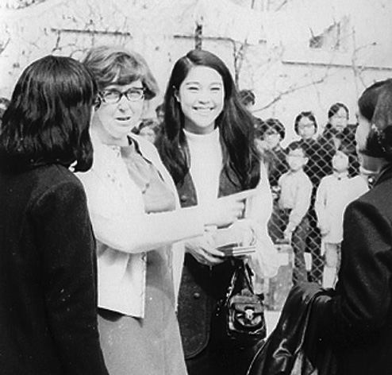  Ms Pilkington with Kwan Man-wai (Miss Hong Kong Festival 1969) | We feel loved so we love ourselves and we love others. We owe a lot to our beloved teachers of what we have become today. What can we give them in return? After the joyful reunion at the grand celebration of Ying Wa’s 100th birthday in 2000, we have been looking forward to meeting Ms Pilkington and other teachers again in the next big party in 2005. Sadly Ms Pilkington has gone now but together we can keep her memory alive. This is the first appeal outside the small circles of friends. Join the campaign. Help pass the word today. Join the campaign. Make someone feel special! I'll keep you posted of the result of your efforts.

Have a peaceful and really special Christmas!
Rosanna MAK Wai Lim
Classmate of ‘68
8 December 2003

